* **UC1 (Login)**

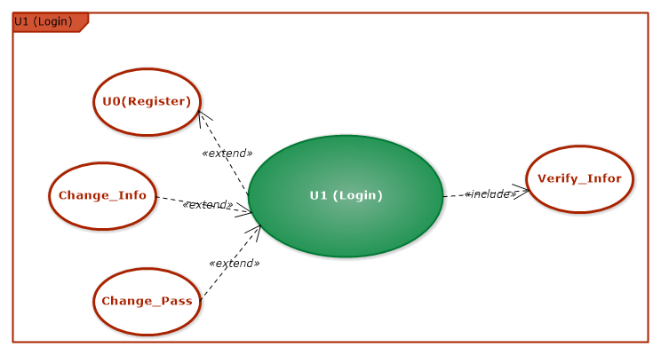

|  |  |
| --- | --- |
| Use Case name | Login (U1) |
| Main Actors | Students, Company’s Agent, Company’s Instructor, Internship Manager Teacher, Instructor, Admin |
| Level | 1 |
| Purpose | Guarantee that user’s authentication and system are safe |
| Precondition | User had an valid account |
| Success confirmation | Valid credentials |
| Activate | User login successfully |
| Main events | 1. Displaying login form 2. User filling his credentials 3. Checking/verifying valid credentials 4. Successfully login messages |
| Exceptions | 1. Warning if credentials is not valid 2. Refilling credentials |

* **UC2 (CV Management)**

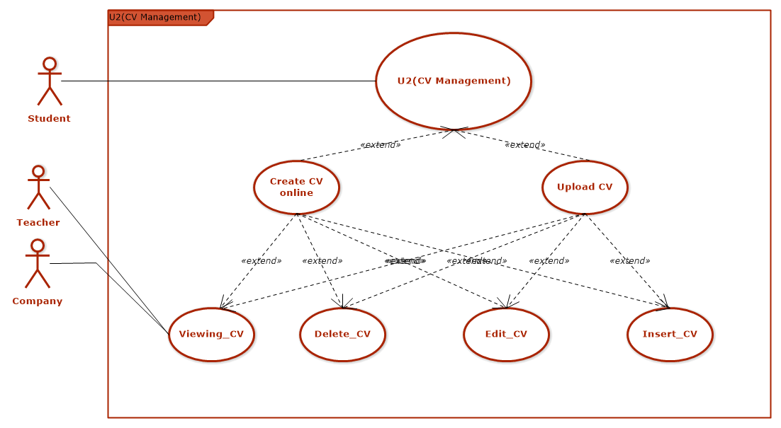

|  |  |
| --- | --- |
| Use Case name | U2 (CV Management) |
| Main Actors | Student |
| Level | 1 |
| Purpose | Supporting student for easily manage their CV |
| Precondition | Student has logged in successfully |
| Activate | Student updated their CV successfully |
| Main events | 1. Student access to CV management section  2. Student choose “Create CV online/Upload CV”  3. Student review and modify their CV (if needed)  4. CV will be submitted and teacher/company are authorized for getting CV contents.  4. Logging out |
| Exceptions | 1. User hasn’t logged in with an authorized email |

* UC5(Submitting internship report)

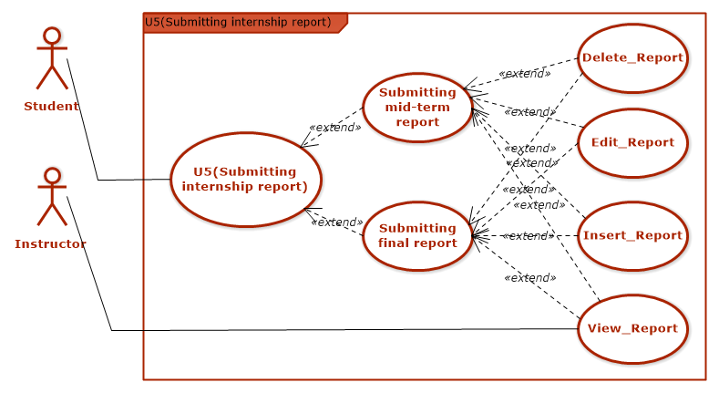

|  |  |
| --- | --- |
| Use Case name | U5 (Submitting internship report) |
| Main Actors | Student |
| Level | 1 |
| Purpose | Supporting student for submitting report punctually |
| Precondition | Student has logged in to system successfully |
| Activate | Student has correctly submitted mid-term and final report |
| Main events | 1. Student logging in to system  2. Student clicks to “Submitting mid-term/final report” section  3. Student choose their report file for submitting.  4. Student clicks submitting.  5. Student review their report.  6. Student can modify their report before submitting  7. Student’s report will be submitted, teacher can give a mark  8. Exiting use case |
| Exceptions | 1. Report submitting is overdue  2. Report is not correctly formatted  3. User hasn’t logged in with an authorized email |

* **UC6 (Topic Management)**

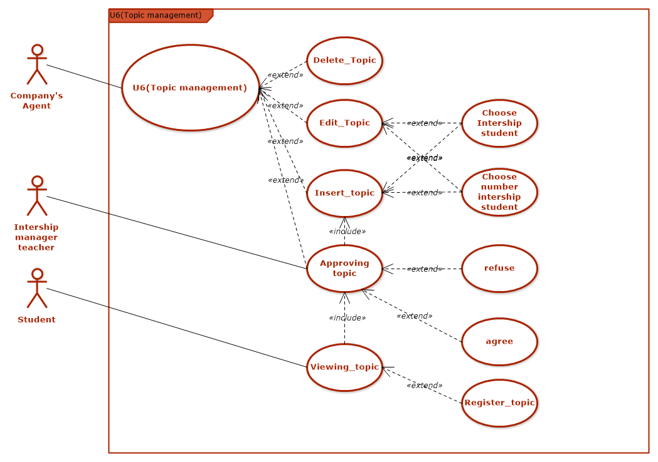

|  |  |
| --- | --- |
| Use Case name | UC6 (Topic management) |
| Main Actors | Company’s Agent , Internship manager teacher |
| Level | 1 |
| Purpose | Supporting company in registering internship topic, internship manager teacher can manage internship topics and select what topic will be suitable for students. Student can view and register his favorite topics |
| Precondition | Student has logged in to system successfully |
| Activate | Internship topic has been submitted successfully and student can read and register |
| Main events | 1. User access to topic management tab  2. Company’s Agent select Insert_Topic/Edit_Topic/ Delete_Topic/Viewing_Topic.  3. Company’s Agent filling topic information. (if he selects Insert/ Edit_Topic)  4. Company’s Agent enter the number of student needed for topic or select certain students based on student’s id (if he selects Insert/ Edit_Topic)  5. Internship manager teacher will access to “Approving topic” to decide which topic will suitable for student’s ability, student’s time and selects approve/reject these topics  6. Company’s Agent will recheck and fix these topics in teacher’s demand then click “Save”  7. Topics list will be displayed on system’s view, allowing student to access and carry out activities  8. Exiting Use Case |
| Exceptions | 1. Registering topics is overdue  2. Company is not correctly register topics  3. Student choose more than 3 topics or topic is not available for register (because there is too much student registered that topic)  4. Internship manager teacher can not approve topic when company’s agent has not submitted topics.  6. Student can not see topic when Internship manager teacher has not approved topic  7. User hasn’t logged in with an authorized email |

* **UC8 (Internship student manage)**

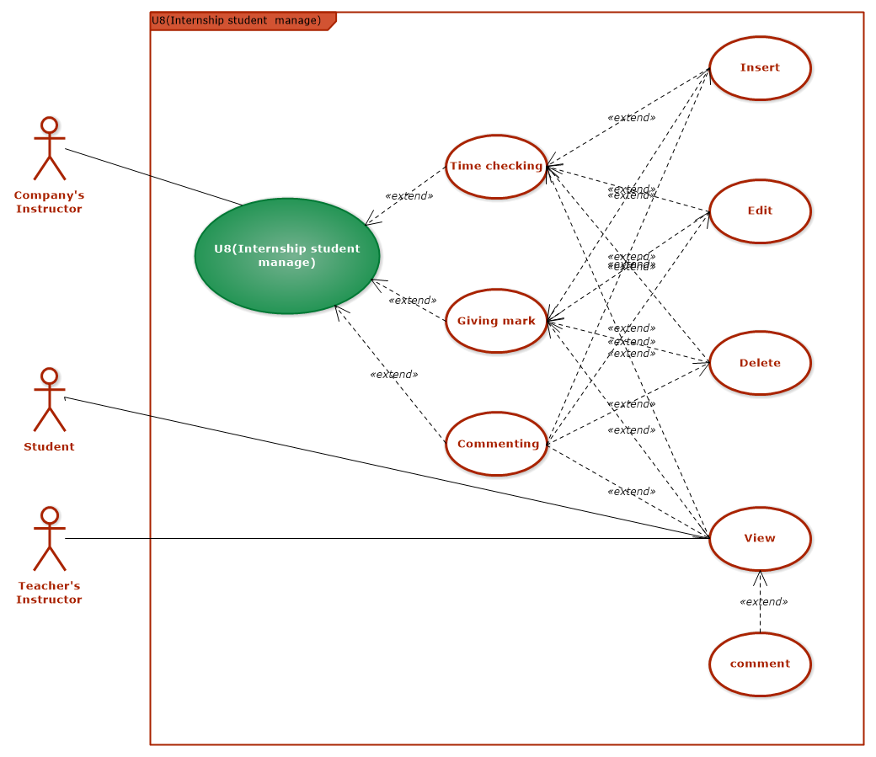

|  |  |
| --- | --- |
| Use Case name | UC8 (Internship manage in company) |
| Main Actors | Company’s Instructor |
| Level | 1 |
| Purpose | Supporting Company’s Instructor, Teacher’s Instructor for tracking student’s internship progress regularly, make judgement on student’s work in company. Student can also track their own progress |
| Precondition | User logging in to system |
| Activate | Complete commenting for student’s internship program, time checking for student  Instructor Teacher and Student can get student’s result in their system |
| Main events | 1. Company’s Instructor access tab “Internship manage in company”  2. Company’s Instructor selects tab Time checking/ Commenting / Giving mark  3. Company’s Instructor enter comment/ mark/time checking for student  4. Company’s Instructor review filled field and click submit.  5. Company’s Instructor information which entered will be submitted to system  7. Instructor Teacher and Student can access and get the comment, mark that Company’s Instructor has given  8. Student can comment if they think that is not suitable  9. Exiting Use Case |
| Exceptions | 1.User hasn’t logged in with an authorized email |

* **UC9 (Submitting detailed report)**

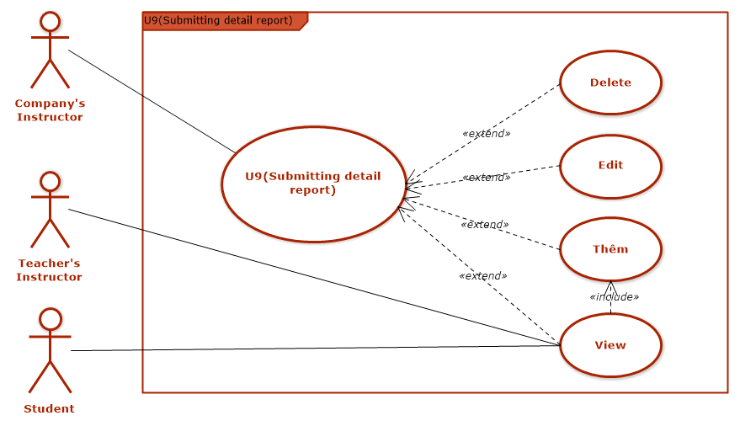

|  |  |
| --- | --- |
| Use Case name | UC9 (U9(Submitting detail report)) |
| Main Actors | Company’s Instructor |
| Level | 1 |
| Purpose | Supporting Student, Teacher’s Instructor to know student’s detailed work content weekly, monthly for arranging suitable work schedule, preparing necessary knowledge, and help Instructor teacher, Company’s Instructor tracking student’s daily, weekly and monthly work easily |
| Precondition | User logging in to system  Company’s Instructor’s submitted topics has been approved by teacher |
| Activate | Company’s Instructor submitted detailed report successfully.  Instructor Teacher and Student can get detailed report’s content |
| Main events | 1. Company’s Instructor access to “Submitting detailed report” functionality  2. Company’s Instructor choose file format  3. Company’s Instructor choose file to upload  4. Company’s Instructor click “Save”  5. Company’s Instructor review detailed report and modify if necessary  6.Detailed report will be submitted to system  7. Instructor Teacher and Student can access to get the content of detailed report and student’s work  8. Exiting Use Case. |
| Exceptions | 1. Instructor Teacher and Student can not get detailed report’s content if Company’s Instructor has not uploaded detailed report successfully  2. Company’s Instructor is not punctually submitted report  3. Company’s Instructor uploaded file which is not correctly formatted  4. User hasn’t logged in with an authorized email. |

* **UC10 (Assign Internship Decision)**

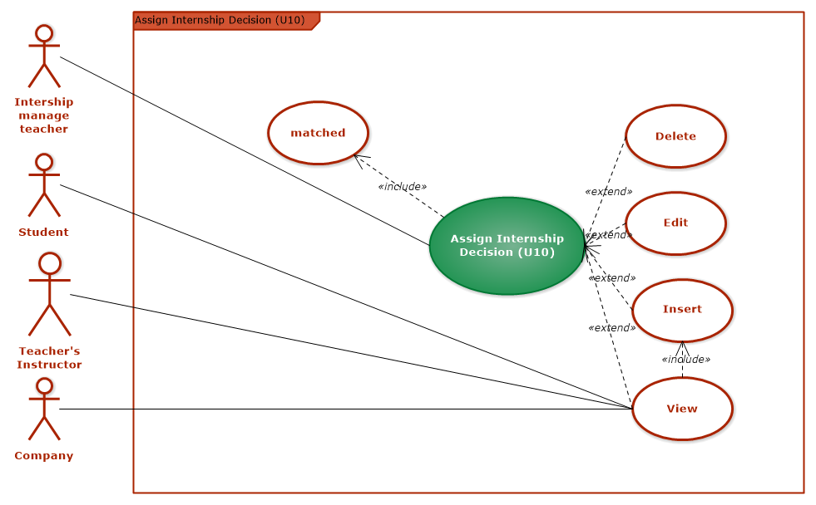

|  |  |
| --- | --- |
| Use Case name | UC10(Assign Internship Decision) |
| Main Actors | Internship manager teacher |
| Level | 1 |
| Purpose | Arranging topic that suitable for student and school’s rule |
| Precondition | 1.User logging into system  2. Comparing process between topic and student’s CV is successfully |
| Activate | Arranging process is successfully, students will be placed for suitable company, Instructor Teacher and Student can get internship program content |
| Main events | 1. Instructor manager teacher access arranging internship functionality  2. In this section, with each student, will be displayed topics, company information about registered company, and the suitable percentage with student. Instructor manager teacher will select topic which is most suitable for student  3. After complete filling, Instructor manager teacher click Save.  4. Instructor manager teacher review arranging internship’s content and modify if necessary.  5. Arranging internship’s content will be submitted to system  6. Instructor Teacher , Company’s Instructor and Student access to arranging internship’s content and get the result |
| Exceptions | 1. User hasn’t logged in with an authorized email.  2. Can not get the arranging internship’s content if Intership manager teacher has not saved arrange internship function |

* **U11 (Reckoning up internship status)**

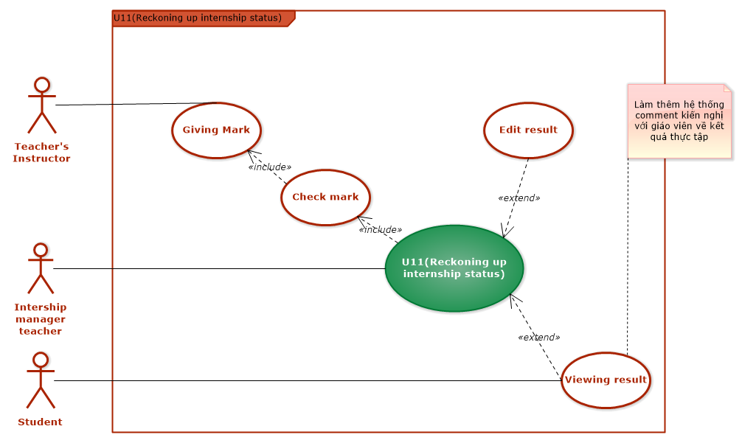

|  |  |
| --- | --- |
| Use Case name | UC11 (Reckoning up internship status) |
| Main Actors | Internship manager teacher |
| Level | 1 |
| Purpose | Through this functionality, Internship manager teacher and student can tracking and getting the student’s result (completed/not completed). If not completed, the student must registered on the next semester |
| Precondition | 1. User logging into system  2. Instructor Teacher has submitted student’s mark to system  3. System processed checking mark ( sum < 4 means not completed) |
| Activate | Listing all students that  + completed internships  + haven’t completed internships  + delay and delay reason ( submitted all required documents and has been approved) |
| Main events | 1. Instructor manage teacher access to section “Reckoning up internship status”  2. Instructor manager teacher review result of internships student  3. Instructor manager teacher check students who has good reasons for delaying, for editing the result to “delay”  4. Instructor manager teacher click “Save”  5. Internship status is submitted to system.  6. Student get their own result  7. Exit usecase. |
| Exceptions | 1. . User hasn’t logged in with an authorized email. |

* **UC13 (User management)**

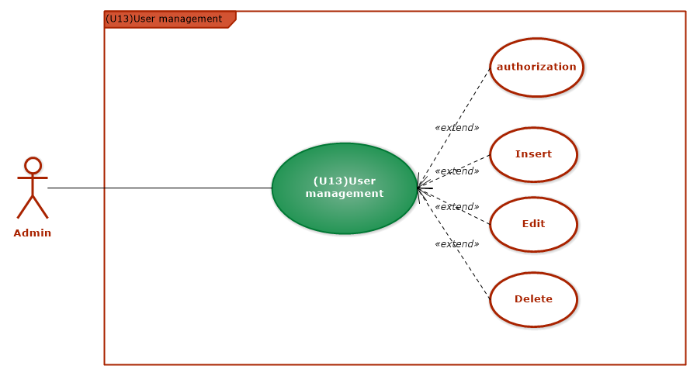

|  |  |
| --- | --- |
| Use Case name | UC13 (User management) |
| Main Actors | Admin |
| Level | 1 |
| Purpose | Managing all system’s user, authorizing user for gaining right accessibility |
| Precondition | Successfully login and can access to all functionalities of the system |
| Activate | Can manage all users, gaining right access for right user |
| Main events | 1. Admin access to “Manage user” section  2. Check for the registering of all user who have been registered based on their email and decentralize the functionalities to every specific group of user.  + Mail: student_num.student.hust.edu.vn will gain the functionalities for student  + Mail: teacher.soict.hust.edu.vn will gain the functionalities for teacher  + Mail with enterprise domain will gain the functionalities for company’s agent or the functionalities for company’s instructor.  3. After the decentralization, click “Save” button.  4. Admin can modify if there is any errors  5. Exiting use case |
| Exceptions | 1. The user did not use the enterprise mail, or student mail will be notified invalid email |

* **UC14 (Score management)**

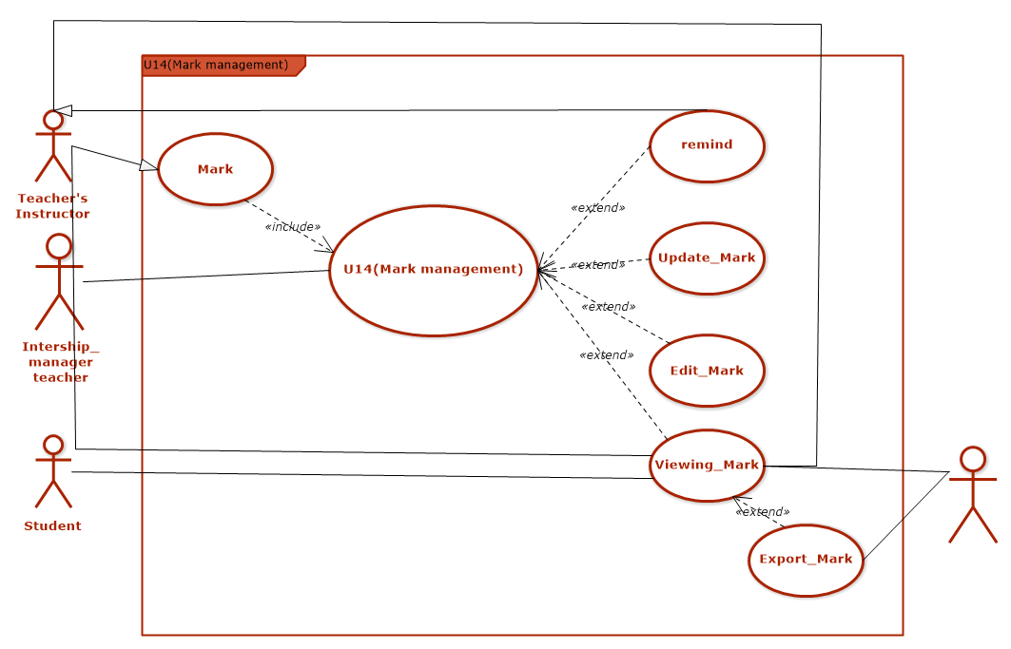

|  |  |
| --- | --- |
| Use Case name | UC14 (Score management) |
| Main Actors | Admin |
| Level | 1 |
| Purpose | Help : Managing mark of all students  functionalities: insert/ edit/ delete student’s mark when student submitting remaking mark and the Instructor teacher’s process of submitting mark has errors  Getting mark for checking mark process, to know who completed/not completed |
| Precondition | * Successful login and can access to all functionalities of the system * Instructor Teacher have done process “Giving mark” and display in the system. |
| Activate | Student’s mark posted to the system successfully. |
| Main events | 1. Intership manager teacher access to section “Mark management”  2. Intership manager teacher check whether Instructor Teacher had given mark? If not, check the time for giving mark and notify Instructor Teacher for giving mark  3. Teacher’s Instructor will be notified.  4. If mark submitting process has any errors, Intership manager teacher can modify student’s marks  5. Mark will be submitted to system  6. Student, Teacher’s Instructor , admin access and get the internship marks.  7.Admin can export mark file. |
| Exceptions | 1. Notify if company’s mail, student’s mail is invalid |

* **U17 (Reckoning up internship registration status)**

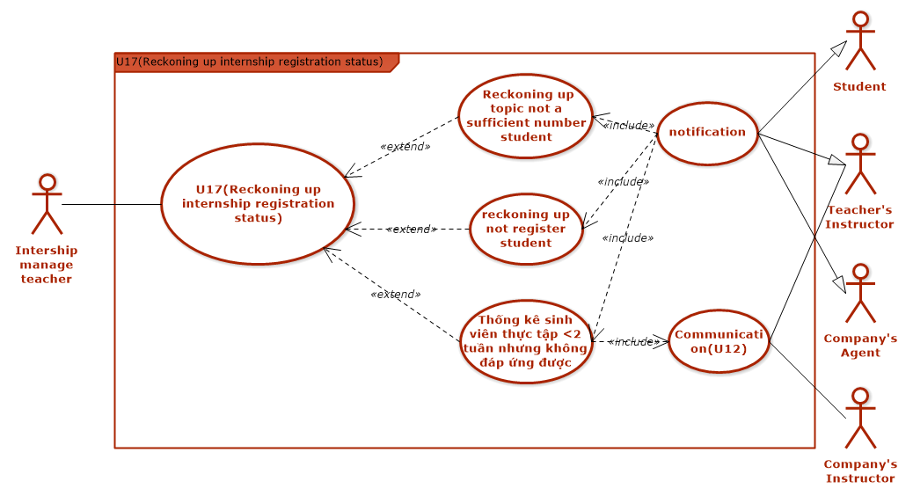

|  |  |
| --- | --- |
| Use Case name | UC17 (Reckoning up internship registration status) |
| Main Actors | Internship manager teacher |
| Level | 1 |
| Purpose | * Listing students who has not registered * Listing which topics has not been fully registered * Listing students who is not meet the requirement when working less than two weeks at company * Reopen registration second time |
| Precondition | * User logged in successfully * Registration has been closed * Communication result between Instructor Teacher and Company’s Instructor is existed |
| Activate | Getting the full list of student who has not registered for internship, topics has not fully registered, banned students  Give notice: listings students need to register again, the remaining topics list. |
| Main events | 1. Internship manager teacher access to analysis internship registration status  2. Chosen criteria:   * Students not registered * Topic insufficient number of students * Students who do not meet the conditions of work at the company after 2 weeks.   3. The system displays a list.  4. Internship manager teacher choose export file  5. Internship manager teacher post a notice on the system  6. Student, Company’s Agent, Teacher’s Instructor get notifications  7. Exit UseCase |
| Exceptions | 1. Error: not reckoning when the system not closed the signup process.  2. Error when not choose criteria. |